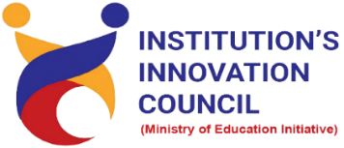
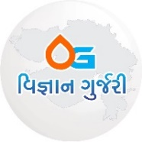

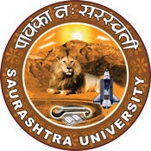

Seminar

on

“Fostering Innovation and Entrepreneurship: Igniting a culture of Change”

10th August 2023
Seminar Hall, Harivandana College
Rajkot

Contents
Saurashtra University – IIC 2
Event Schedule 2
Event Registration Link 2
Brief about Event 3
Key Points 4
Outcome 4
About the Speaker/Chief Guest 4
Connect Us: 6

Saurashtra University – IIC
The university is dedicated to instruction, research, and extending knowledge to the public (public service). Ministry of Education (MoE), Govt. of India has established ‘MoE’s Innovation Cell (MIC)’ to systematically foster the culture of Innovation among all Higher Education Institutions (HEIs). The primary mandate of MIC is to encourage, inspire and nurture young students by supporting them to work with new ideas and transform them into prototypes while they are informative years. Saurashtra University is one the Organization that have constituted the IIC to foster the vision of MoE and be a part for the promotion and development of innovation ecosystem.

Event Schedule

Event Registration Link

bit.ly/SUSEC-HRVDN

Brief about Event

SU start-up and Entrepreneurship Council and IIC Saurashtra university was organized session on “Fostering Innovation and Entrepreneurship: Igniting a Culture of Change" on 10th August 2023 at seminar hall of Harivandana college Rajkot. Mr. Rahul Bhambhani gave basic information regarding student start-up policy and innovation. An event was started with the lighting of a lamp. Mr. Sagar Babaria welcomed the guests, speakers and participants of the program. Dr. Ranjan C. Khunt, Dr. Narendra Dave, Mr. Sagar Babariya, Mr. Parth Sejpal all guests were welcomed with a token of gratitude and a memento gift. Dr. Narendra Dave sir gave inspirational speech for students. He encouraged the students to appear for the civil services exam. Also, gave speech on young innovators. Dr. Ranjan Khunt explained about “Pradhan Mantri YUVA Yojana” and “Atmanirbhar Gujarat” and Madam gave information about SUSEC and SSIP policy.

During the event, the guest speaker Mr. Parth Sejpal provided a brief overview of SUSEC and encouraged students to bring innovative concepts to Saurashtra University's Incubation Centre. The students gained insights into the concepts of "what constitutes innovation," "how innovation differs from invention," and "the true essence of the term discovery." Sir further stated that innovation involves making changes to existing products and gave several illustrative examples to underscore this point. An invention refers to the creation of an entirely new product, process, device, method or concept that does not already exist.

It was emphasized that the first step is to begin. To initiate the process, you must delve a bit deeper into everything around you when someone faces the persistent issue of discomfort while cutting onions or chilies, the solution lies in the creation of a chopper machine; this is invention. Deactivate the autopilot and stay conscious of your surroundings so you will get better solution. Recall the events of your day and reflect on any challenges you encountered. Engage with science fiction literature and movies to stimulate your imagination and explore futuristic scenarios. By splitting the process into these two phases, you ensure a comprehensive approach to product development. The design phase focuses on the product's visual and user experience aspects, while the engineering phase hones in on technical specifications, functionality, and integration.

The minimum viable product is works like prototype and looks like prototype. MVP is ready, now what? do user trials. you must be able to sell the prototype to paying customer if needed. get honest feedback from strangers. Add features only if many users demand it. At the launch start the work for the launch during the MVP stage.

Sir explained about website promotion and social media marketing. He then explained the process and legal aspects for each start up. If your company is a start-up, it must meet these criteria to be considered eligible for DPIIT Start-up accreditation. Criteria are age of company, type of company, annual turnover, parent entity affected.

Key Points
During the session, below mentioned points were discussed:

- Execution is worth more than an idea.
- How innovation works?
- How to start and how to generating ideas?
- Innovation process and MVP launch.
- Understanding the process and legal aspects
- FAQs related to innovation?

Outcome

The primary goal of the event was to provide students with a comprehensive understanding of startups, innovation, inventions, and various government schemes tailored for startups. Shri Narendra Dave Sirs insightful words inspired students to delve deeper into their chosen fields of study. During the event, Mr. Parth Sejpal delivered a detailed presentation on innovation, emphasizing the significance of introducing novel approaches to existing solutions. He also highlighted the importance of recognizing pre-existing elements and differentiating between various types of innovations.

The discourse on the innovation process encompassed essential stages such as data analysis, idea generation, effective problem-solving, prototyping, and invaluable user feedback. Furthermore, participants were made aware about the procedure for registering a company under the Department for Promotion of Industry and Internal Trade (DPIIT). This comprehensive discussion aimed to equip students with a holistic view of the startup ecosystem, nurturing their understanding of innovation, entrepreneurship, and the practical steps necessary to transform ideas into successful ventures.

About the Speaker/Chief Guest

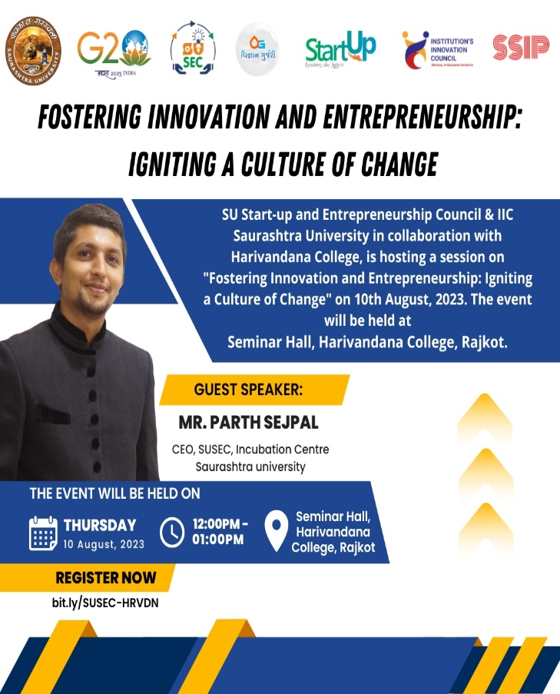

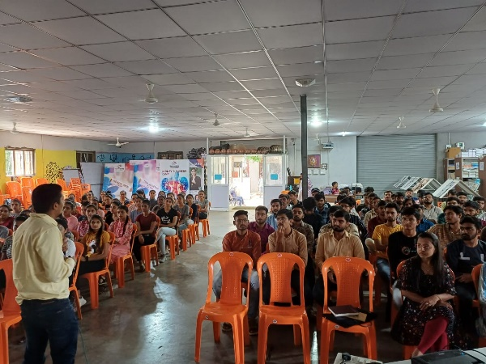
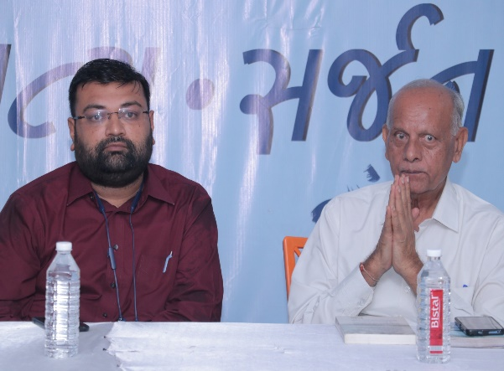

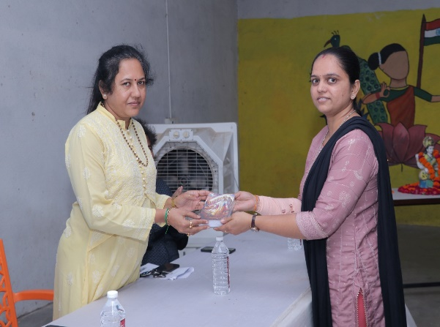
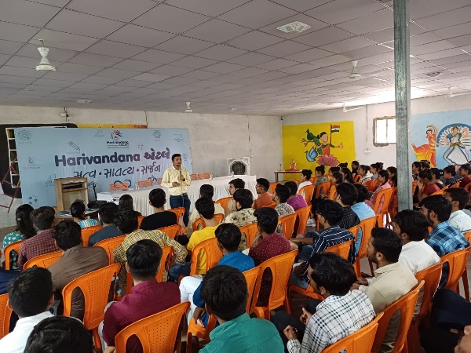

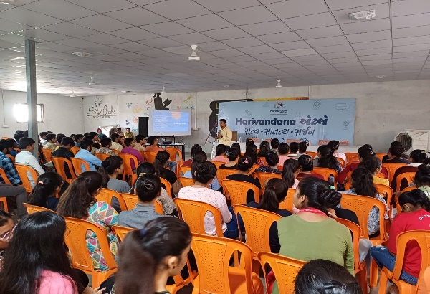
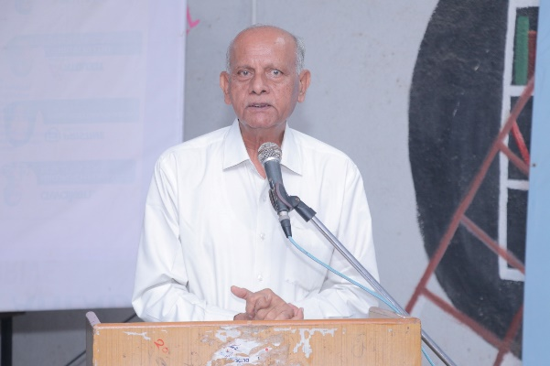

Connect Us:

https://www.linkedin.com/company/susec iic@sauuni.ac.in
https://www.facebook.com/iicsauuni https://bit.ly/SUSECLocation
https://www.instagram.com/susecrajkot https://bit.ly/SUSEC-youtube

